EXPERIMENT 3

NAME: JAI GANESH S

ROLL NO: 240701199

Create a prototype with familiar and unfamiliar navigation elements. Evaluate ease of use with different user groups using proto.io

Screen 1 – Home
The first screen introduces the application with the shop name “E-Sport Shop.” It is simple and minimal, containing only the brand title and an Explore button. This acts as the entry point for users, guiding them to start browsing products. The design suggests a clean landing page with a single clear action.

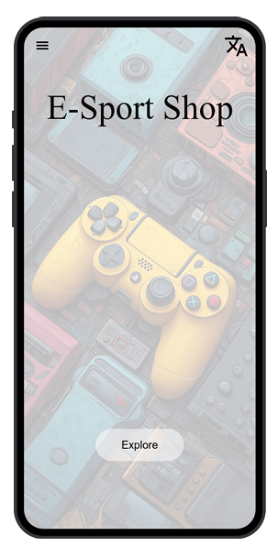

Familiar Elements
- =This is Menu bar for more options
- Standard “Explore” button for navigation

Unfamiliar Elements
- =This is translation bar for changing a language
- Minimal header/footer context

Screen 2 – Profile & Navigation

This screen provides the navigation menu. It includes a back arrow (‹) for returning to the previous page and several menu options: Profile, t Shop, Cart, Settings, About, Explore. These options represent the main sections of the app. However, the label “t Shop” appears incomplete, which may confuse users. Overall, this page is meant to give quick access to different parts of the shopping experience.

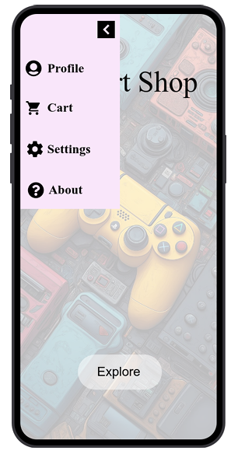

Familiar Elements
• Common navigation items: Profile, Cart, Settings
• Back navigation arrow (“‹”)

Unfamiliar Elements
• “About”=button for about,what is this page

Screen 3 – Product Listing

The third screen displays a list of items under the heading “Available Iteams” (noting the spelling error). The listed products are: Cooler, Finger Sleeve, PC Cooler, Controller, Gaming keyboard and mouse, and PS-5. An Explore button is also present. This screen functions as the product catalog, showing users the available items they can browse or purchase.

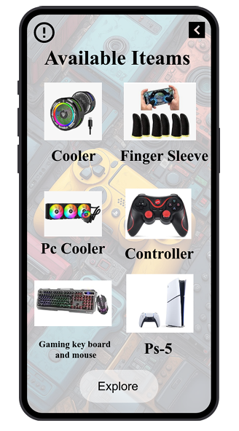

Familiar Elements
- “<” = go to back page
- “Explore”= button

Unfamiliar Elements
-  =page error(some date is not fetching)

Screen 4 – Product Details (Gaming Keyboard & Mouse)

This page focuses on a specific product: Gaming keyboard and mouse. It provides detailed specifications in a structured list:

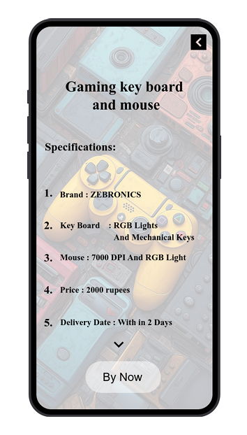

Familiar Elements
- “<” = go to back page
- “Buy Now” button for purchase

Unfamiliar Elements
- = this button is extra points

Screen 5 – Order Confirmation

The final screen confirms the purchase. It shows a congratulatory message: “Congratulations – Order is Booked.” A Go to Home button is provided to return to the main page. This screen completes the shopping flow, reassuring the user that their order has been placed successfully.

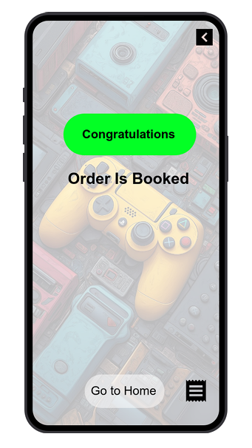

Familiar Elements
- “<” = go to back page
- “Go to Home” button for navigation

Unfamiliar Elements
-  = this button is down load the booking recept

Conclusion
The prototype demonstrates a straightforward e-commerce journey:
- Starting at the home page.
- Navigating through menu options.
- Viewing a product list.
- Checking product details.
- Receiving order confirmation.
Each screen contains only the essential elements needed for the flow. While the design is functional, some labels and details (like “t Shop” and “Iteams”) could be refined for clarity and professionalism.

